Mount Kenya University
School of computing and informatics
BIT4107-mobile application development practical Report

MILEWISE: VEHICLE MAINTENANCE AND EXPENSE TRACKING MOBILE APPLICATION

Student Name: David Maina Mukundi

ADM NO: BIT/2024/37478

Course: Bachelor of Science in Information Technology

Department: Computing and Informatics

Submission Date: June 2026

Table of contents
Mount Kenya University 1
BIT4107-mobile application development practical Report 1
MILEWISE: VEHICLE MAINTENANCE AND EXPENSE TRACKING MOBILE APPLICATION 1
Table of contents 1
1.0 Introduction 3
1.1 Background Information 3
1.2 Problem Statement 3
2.0 Methodology 3
3.0 System Analysis 4
3.1 Functional Requirements 4
3.2 Non-Functional Requirements 4
3.3 Wireframe Design 4
4.0 Results and Discussion 7
5.0 Conclusion and Recommendations 8
6.0 Weekly Progress 8
6.1 Week 1: Development Environment Setup 8
6.2 Week 2: Mobile Development Environment 9
6.3 Week 3: User Interface Design 11
7.0 Creativity and Innovations 12
8.0 Task Distribution 12
References 13

1.0 Introduction

1.1 Background Information
Vehicle ownership comes with numerous responsibilities, including regular maintenance, servicing, and expense management. Many vehicle owners rely on memory, handwritten notes, or scattered records to track fuel costs, service schedules, tire replacements, insurance payments, and repair expenses. This often leads to missed maintenance appointments, poor financial tracking, and increased vehicle operating costs.
With the growth of mobile technology, smartphone applications provide an effective way to manage and organize vehicle-related information. Mobile applications offer convenience, accessibility, and real-time record management, enabling users to monitor their vehicles from anywhere.
This project focuses on the development of MileWise, a mobile application designed to assist vehicle owners in tracking vehicle expenses, maintenance schedules, mileage records, and service history. The application aims to simplify vehicle management while improving maintenance planning and cost monitoring.

1.2 Problem Statement
Many vehicle owners struggle to maintain accurate records of maintenance schedules and vehicle expenses. Traditional methods such as paper records and memory-based tracking are prone to loss, inaccuracies, and missed service dates.
Failure to maintain proper records may result in delayed maintenance, unexpected breakdowns, increased repair costs, and poor budgeting. Therefore, there is a need for a centralized mobile solution that enables users to manage vehicle maintenance and expenses efficiently and conveniently.

2.0 Methodology
The development of MileWise follows a structured mobile application development approach.
The first phase involved identifying the problem and gathering user requirements. Research was conducted to understand common challenges faced by vehicle owners regarding maintenance tracking and expense management.
The second phase focused on setting up the development environment using Visual Studio Code, Expo, and React Native. The application architecture and technology stack were selected based on simplicity, scalability, and ease of development.
The third phase involved designing the user interface using Figma. Wireframes were created for the main application screens, including the Dashboard, Add Expense, Service Reminder, and Maintenance History screens.
The next development phases will involve implementing the application features, testing functionality, and refining the user experience before deployment.

3.0 System Analysis
System analysis was conducted to identify the functional requirements and major components of the MileWise application.

3.1 Functional Requirements
The system shall:
- Allow users to register vehicle information.
- Record vehicle expenses.
- Maintain service history records.
- Display upcoming maintenance schedules.
- Provide maintenance reminders.

3.2 Non-Functional Requirements
The system shall:
- Be user-friendly.
- Provide fast response times.
- Store data locally using AsyncStorage.
- Support Android mobile devices.
- Maintain data accuracy and consistency.

3.3 Wireframe Design
The MileWise user interface was designed using Figma.
The following screens were designed:
- Splash Screen
- Vehicle profile
- Dashboard Screen
- Maintenance Tracker
- Service Reminder Screen

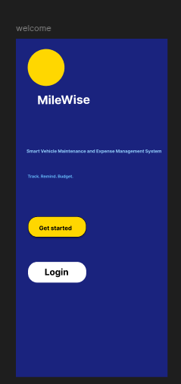
Fig 1 Splash screen

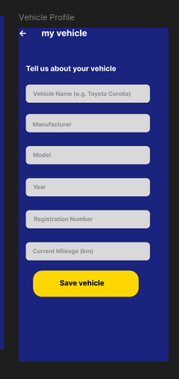
Fig 2 Vehicle profile screen

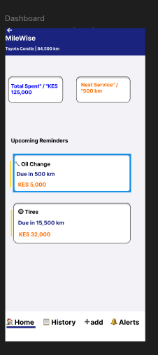
Fig 3 Dashboard Screen

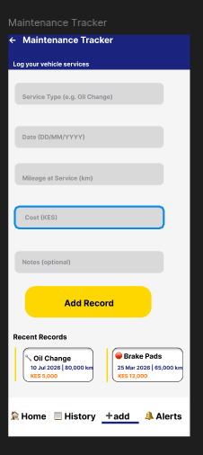
Fig 4 Maintenance tracker

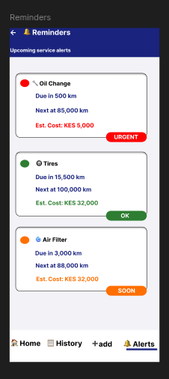
Fig 5 Service reminders

4.0 Results and Discussion
At the current stage of development, the project has successfully completed the planning, environment setup, and user interface design phases.
The development environment was configured using Visual Studio Code and Expo. Initial testing confirmed successful deployment of React Native applications to a physical Android device using Expo Go.
User interface wireframes were created using Figma to establish the application's visual structure and navigation flow. The wireframes provide a clear blueprint for the upcoming implementation phase.
These activities have established a solid foundation for the development of MileWise and reduced potential design-related issues during implementation.

5.0 Conclusion and Recommendations
The initial phases of the MileWise project have been completed successfully. Requirements for gathering, environment setup, and interface design activities have provided a clear understanding of the project's scope and objectives.
The next phase will focus on implementing the application's core functionality, including expense tracking, mileage recording, maintenance scheduling, and data storage.
Future enhancements may include cloud synchronization, push notifications, multiple vehicle support, and maintenance analytics.

6.0 Weekly Progress

6.1 Week 1: Development Environment Setup
Visual Studio Code and Expo Go were installed and configured. Initial research on React Native and Expo was conducted. During setup, Expo SDK compatibility issues were encountered and resolved by downgrading from SDK 55 to SDK 54.
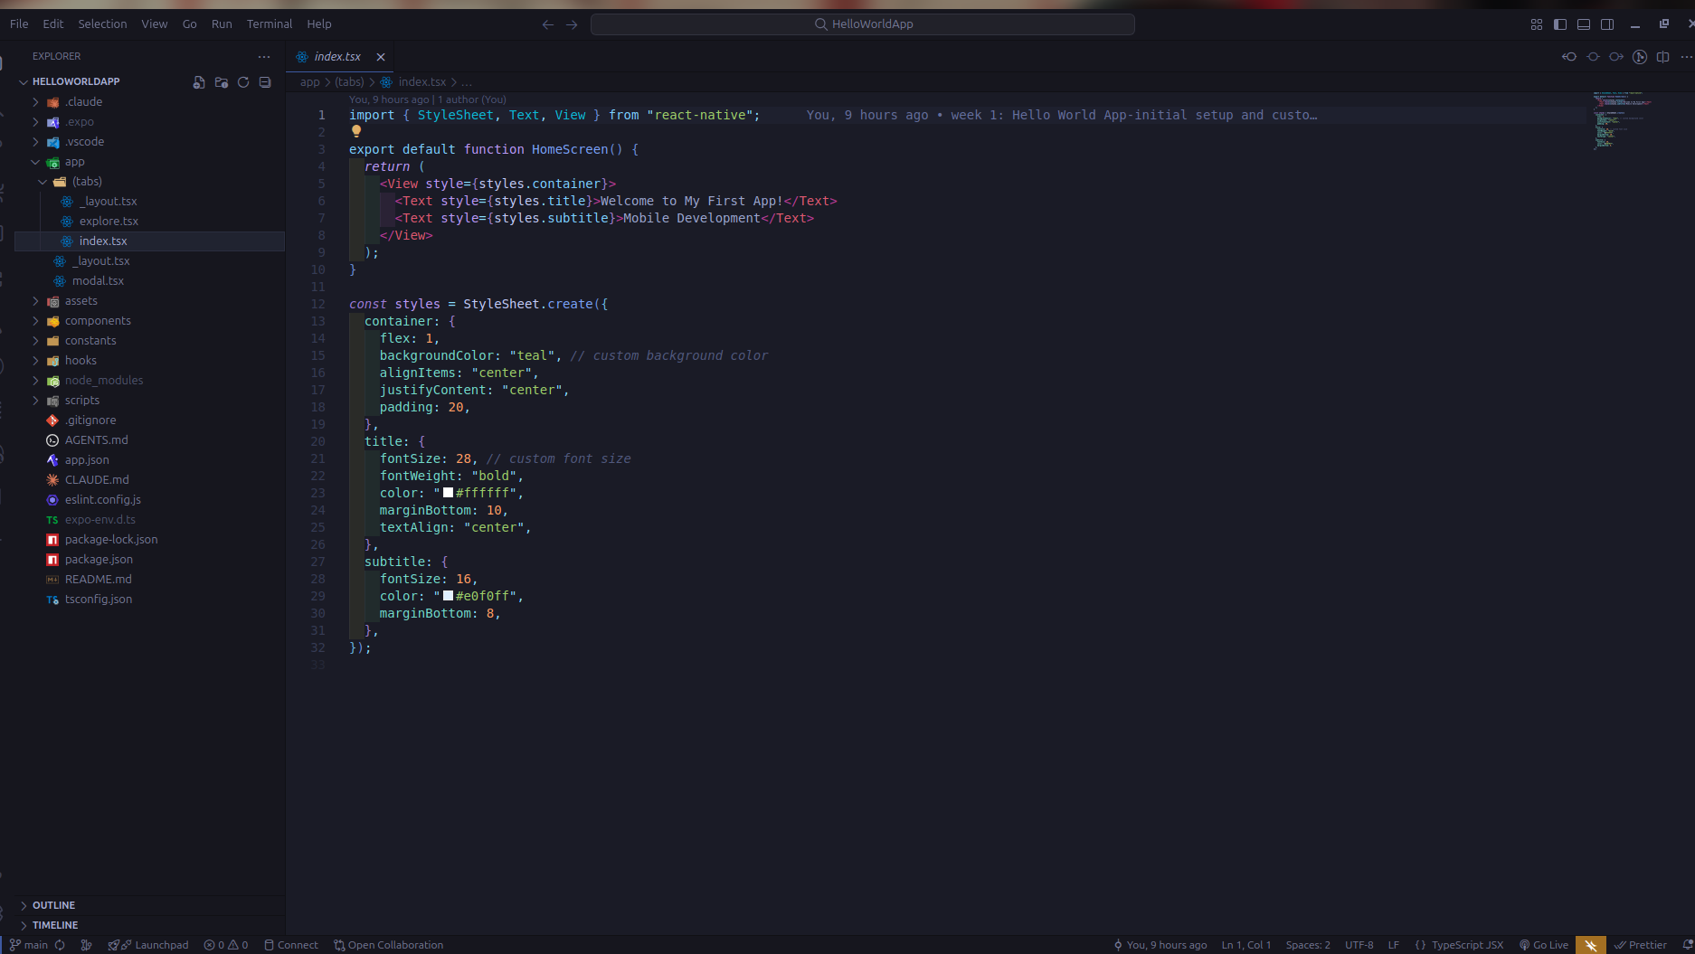Fig 6 Installed vs code

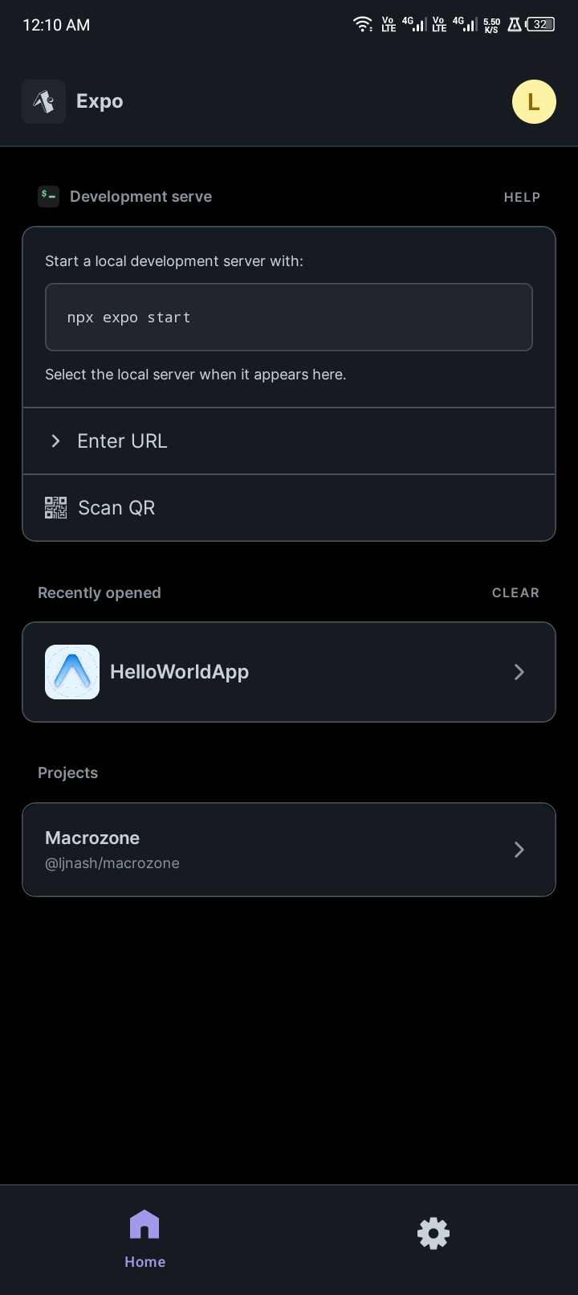
Fig 7 Installed expo Go on mobile device

6.2 Week 2: Mobile Development Environment
A React Native project was launched using Expo. The development server was started using npm, and the generated QR code was scanned using Expo Go. The application was successfully displayed on a physical Android device.

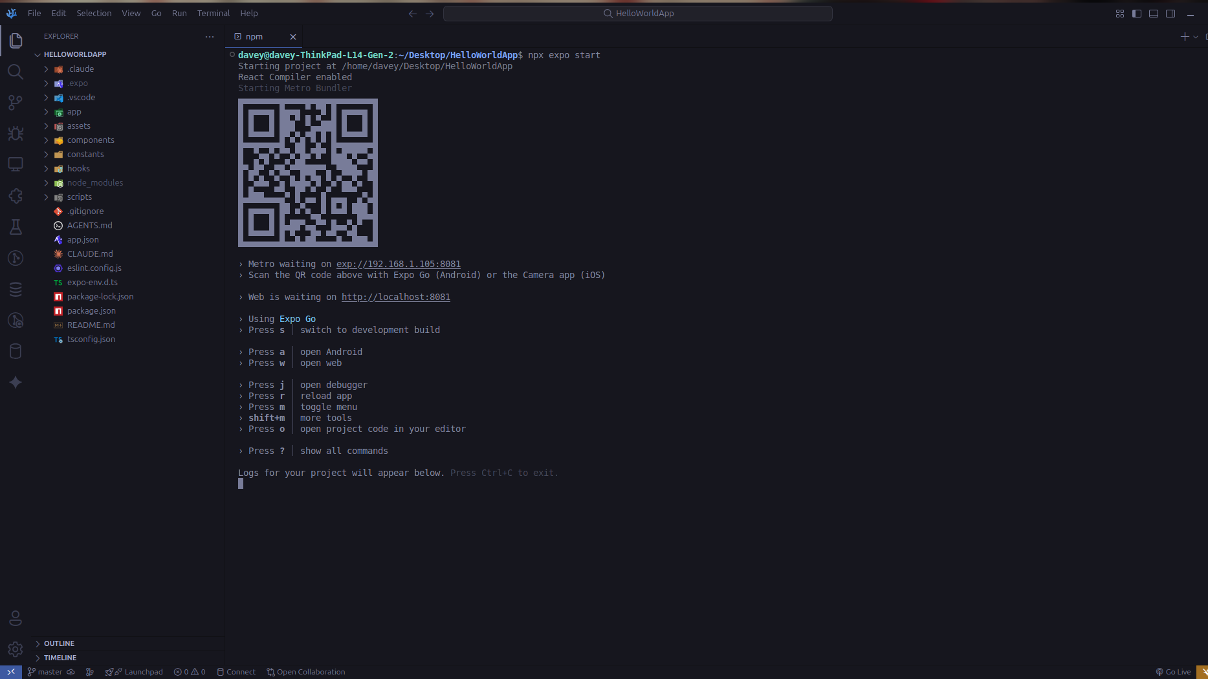Fig 8 Running code with Expo Go

Fig 9 Output displayed on Mobile device

6.3 Week 3: User Interface Design
Wireframes for the MileWise application were created using Figma. Key screens including welcome, Vehicle Profile, Dashboard, Service Reminder, and Maintenance History were designed to improve navigation and usability.
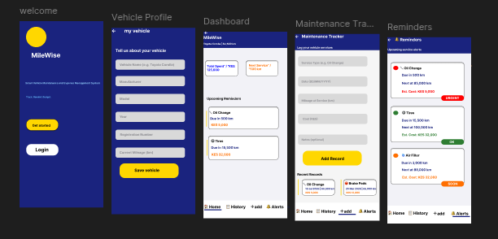
Fig 10 Figma designs

7.0 Creativity and Innovations
MileWise introduces a centralized approach to vehicle maintenance and expense management. The application combines maintenance scheduling, mileage tracking, and expense monitoring into a single mobile platform.
The use of intuitive mobile interfaces and structured maintenance records aims to improve user convenience and encourage proactive vehicle maintenance.

8.0 Task Distribution

Task | Description | Week
Project planning | Define project Scope and requirements. | Week 1
Environment setup | Install and configure development tools. | Week 1
Mobile Testing | Development tools  Deploy React Native app to Android device | Week 2
Wireframe Design | Design application screens using Figma. | Week 3
Application development | Implement Application functionality. | Week 4 onwards
Testing and Debugging | Verify functionality and fix issues.
Documentation | Prepare reports and logbook | Throughout project

References
React Native Documentation. https://reactnative.dev
Expo Documentation. https://docs.expo.dev
Figma Documentation. https://help.figma.com
Pressman, R. S., & Maxim, B. R. (2019). Software Engineering: A Practitioner's Approach (9th Edition). McGraw-Hill Education.

